Jack Melcher

ID: 67574625

EECS 20

Lab 1

Step II and III

Code:

.ORIG x4000

LEA R0, LABEL1

TRAP x22

LEA R0, LABEL2

TRAP x22

LEA R0, LABEL3

TRAP x22

TRAP x25

LABEL1 .STRINGZ "C Programming"

LABEL2 .STRINGZ "Spring 2015"

LABEL3 .STRINGZ "UCI"

.END

Console Output:

Before Simulation

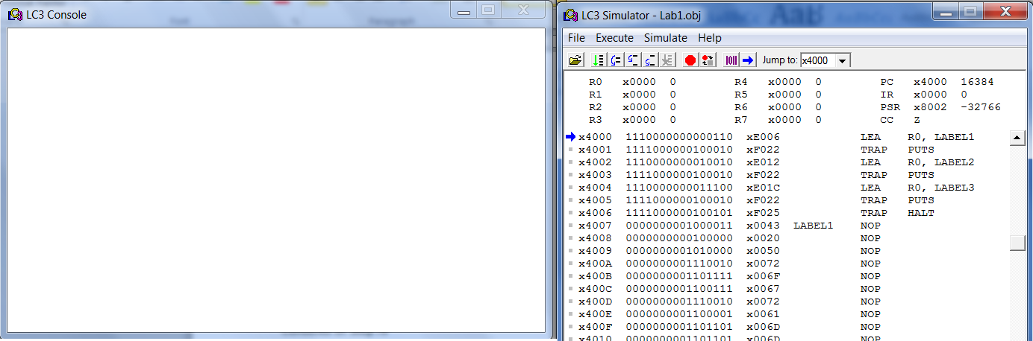

After Simulation

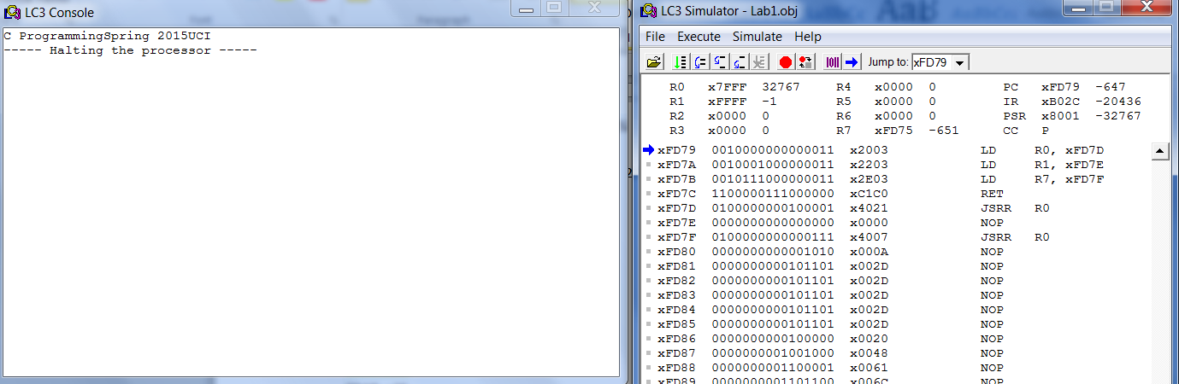

Step IV

Code:

.ORIG x4000

LEA R0, LABEL1

TRAP x22

LEA R0, LABEL2

TRAP x22

LEA R0, LABEL3

TRAP x22

LEA R0, LABEL4

TRAP x22

TRAP x25

LABEL1 .STRINGZ "Jack, "

LABEL2 .STRINGZ "Melcher, "

LABEL3 .STRINGZ "Computer Engineer, "

LABEL4 .STRINGZ "EECS20"

.END

Console Output:

Before Simulation

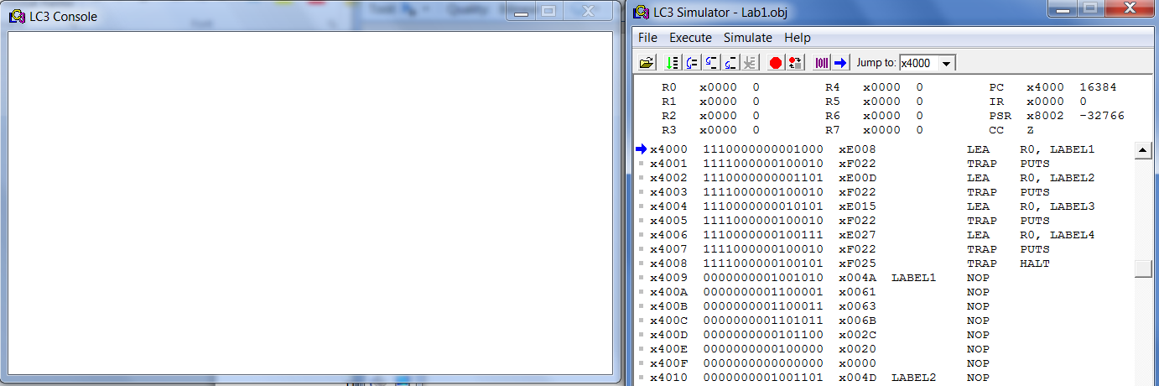

After Simulation

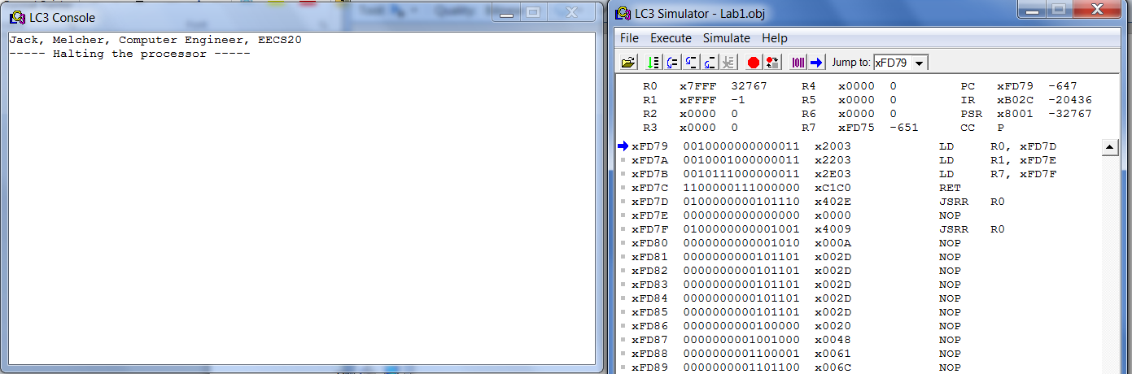

Step V

Code:

.ORIG x5000

LEA R0, LABEL1

TRAP x22

LEA R0, LABEL2

TRAP x22

LEA R0, LABEL3

TRAP x22

TRAP x25

LABEL1 .STRINGZ "C Programming"

LABEL2 .STRINGZ "Spring 2015"

LABEL3 .STRINGZ "UCI"

.END

Console Output:

Before Simulation

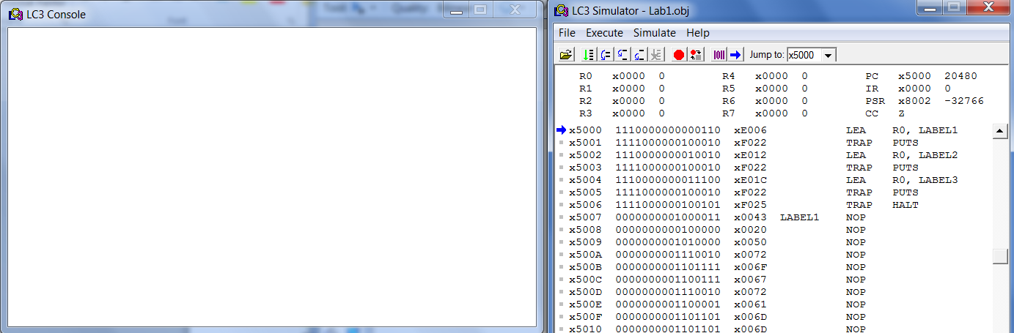

Note: The program now begins at memory address x5000

After Simulation

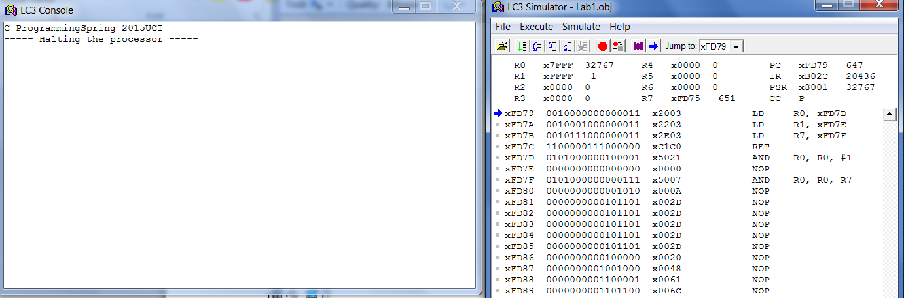

LC-3 Psuedo Code

.ORIG

Where the code is put in memory, the starting location of the program

PC is set to the .ORIG value prior to execution

Example: .ORIG x4000 means the code begins at memory address x4000

TRAP x22 (PUT)

Prints a string onto the console window

Address of the first character in string is in R0

.STRINGZ

Declares a string of characters

Example: string_name .STRINGZ "Content of string"

TRAP x25 (HALT)

Ends the program with the use of a forever loop.

.END

Where the assembly stops